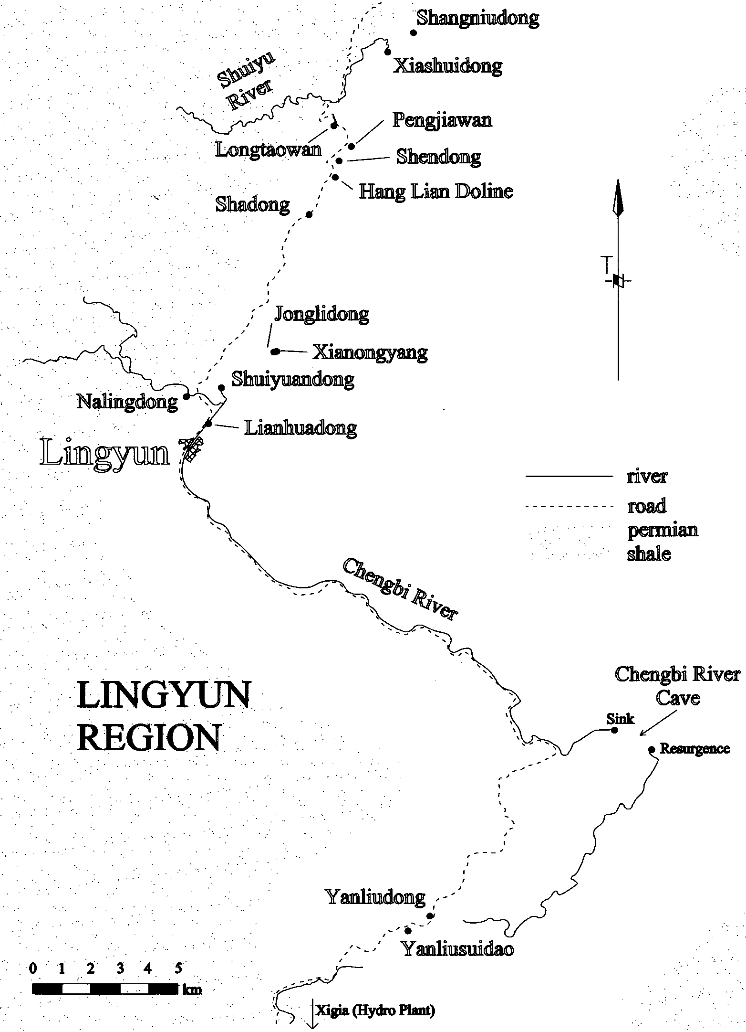
Figure 26: Map of Lingyun region in NW Guangxi Province, P.R. China, showing location
of caves explored in two areas north and south of Lingyun County town during “Guangxi 2000” expedition. Note: the near proximity of caves to main road. [Map sourced from the expedition report (Campion, 2001) in The YRC Bulletin, Issue 15 (Summer 2001): p. 8.]

(a) Karst Area to North of Lingyun (see map above in Figure 26)

Jong Lidong:
Altitude: 596.5m; total plan length of survey shots = 87.04m; vertical range = 14.55m. Small cave with 2.5m wide entrance in overhanging cliff; located a few hundred metres ESE of the village of Nong Yang.

Xianong Yang:
Altitude: 598m; total plan length = 60.34m; vertical range = 12.65m. A small cave with two connected chambers.

Long Taowan (Figure 27):
Altitude: 729m; total plan length = 58.08m; vertical range = 57.77m. A 4 metre wide entrance to rift-like cave development that appears to follow a fault; cave has average angle of about 45º. Rift becomes increasing narrow towards the limit of exploration in precarious boulder choke. Spectacular water washed flowstone in lower level that could bot be accessed.

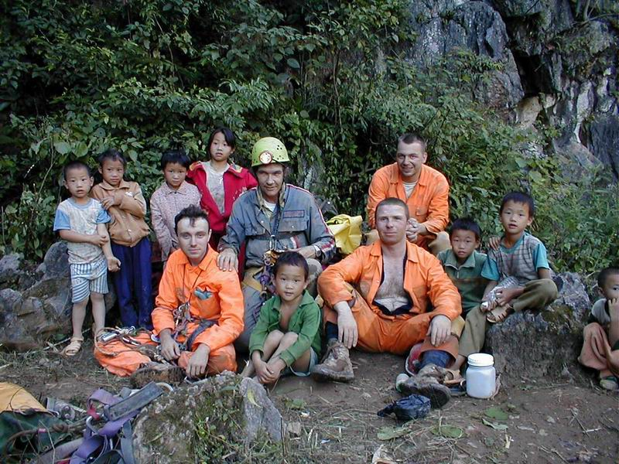

Figure 27: Posing for photograph with village children after exiting Long Taowan, north of Lingyun; curious children and adults regularly follow expeditioners to cave sites in China..

Lian Huadong (= Lotus Leaf Cave)
Altitude: 461m; total plan length = 466.47m; vertical range = 10.55m. The entrance to this cave is situated close to the eastern bank of the Chengbi River near the northern limits of Lingyun. Used regularly by villagers for incense burning religious ceremonies, Lian Huadong is also being considered for development as a tourist cave.

Peng Jiawan (potential show cave)
Altitude: 708m; total plan length = 1712.54m; vertical range = 104.64m. Peng Jiawan is a major cave, that has obviously been known to the locals for some time. Concerned by the “illegal” removal of speleothems, local villagers sealed the cave entrance over a decade ago by blasting down the cliff face. Situated beneath a slight overhang in a large (40m wide x 70m deep) vertical walled collapse depression with thick jungle forest, the entrance had to be excavated and exhumed to gain access. Considered to have great potential as a show cave, the main cave passage terminates at the base of a steep boulder slope: at the top of which is an impressive chamber measuring 100m x 100m and 40-60m high (see Figure 28).
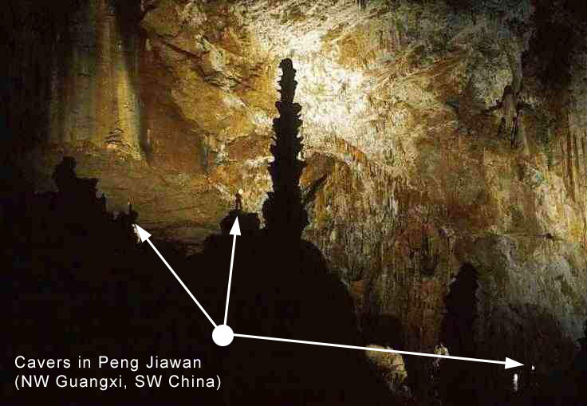

Figure 28: Arrow lines pointing to cavers photographing the massive 100m x 100m end chamber in Peng Jiawan. (Original photograph by Bruce Bensley.)

Shadong (= Sand Cave) Fig. 29, below)

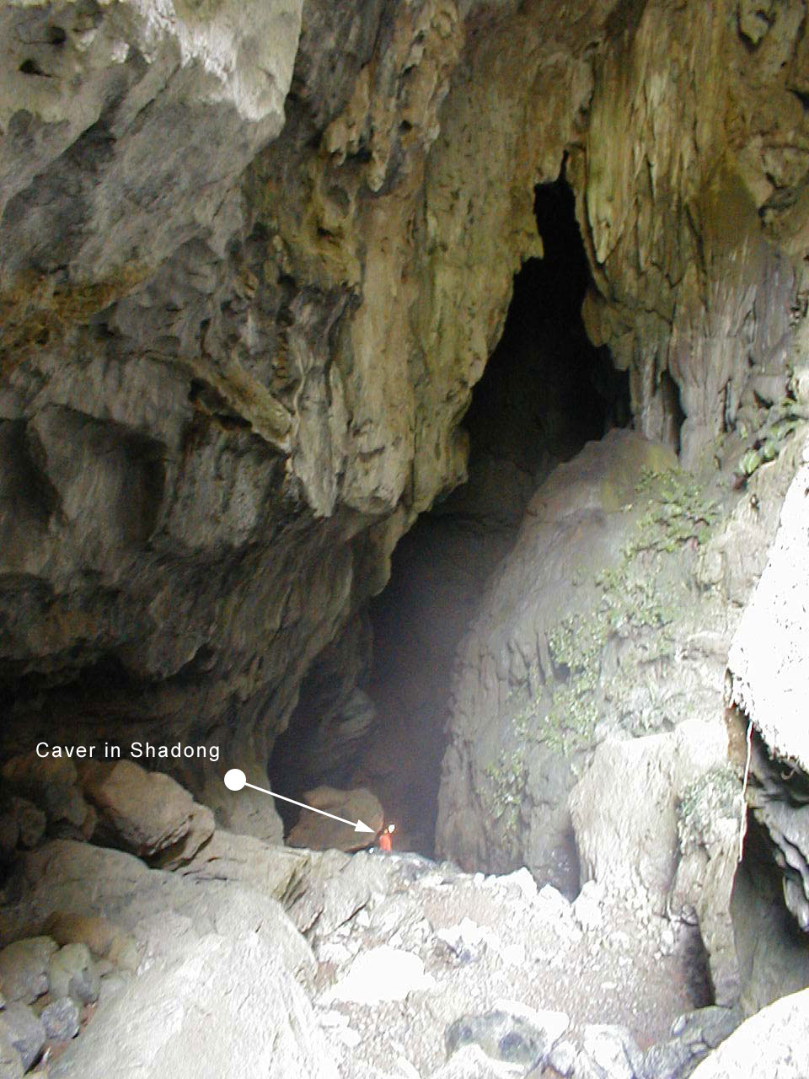
Figure 29: The 45m high stream swallet entrance to Shadong, north of Lingyun, with arrow showing caver descending to base of entrance rubble slope.

Altitude: 649m; total plan length = 2855.13m; Surveyed vertical range = 120.75m. Shadong was the most extensive cave discovered during our expedition. The large entrance (25m wide and over 45m high) is situated at the head of a blind valley, carrying a stream in times of heavy rain. Shadong has multiple levels, with highly decorated fossil chambers and upper level tributary passages with streams connecting to a larger main lower level river passage via underground waterfalls that were impossible to descend. It was obvious that the local people had visited this cave but to what extent they went beyond the entrance was unknown until Arthur Clarke met a fisherman in the cave. While approximately 1.5km into Shadong collecting a new species (possibly new genus and/ or new Family) of blind cave shrimps Arthur was disturbed by a local villager. (Wearing only plastic flip-flop sandals on his feet and clad simply in T-shirt and shorts, but carrying a torch with spare batteries and his onion bag fishing net, it was obvious that he was there to net the very same rare species of shrimp, collecting them to eat!).

Shendong (= “Deep” Cave)
Altitude: 670m; total plan length = 173.59m; vertical range = 19.16m. Although not completely explored, after we reported the survey dimensions of Shendong to our guide (and interpreter) he thought we should probably re-name the so-called “Deep Cave”, perhaps calling it “Nong Yin Feng” or “Ying Feng” - a name based on the two villages that the cave was located between: Nongying or Nongyin (to the north) and Nongfeng (south). The entrance to Shendong is located in a boulder choke at the base of cliff on the eastern side of a large doline / uvala complex. Beyond the boulder choke, a small stream channel tributary drains through small avens, then descends steeply into a swirling water funnel leading to undescended depths (Clarke, 2001a).. Connecting at the funnel rim a narrow and meandering passage continues upstream, widening into extensive mud-floored chambers including a 15 m high chamber with large hipposiderid bats (Figure 31). Figure 30 below shows the troglobitic carabid beetle [Guizhaphaenops (Guiaphaenops) lingyunensis n. subgen., n. sp.] discovered in this cave, not far from the entrance (Deuve, 2002).

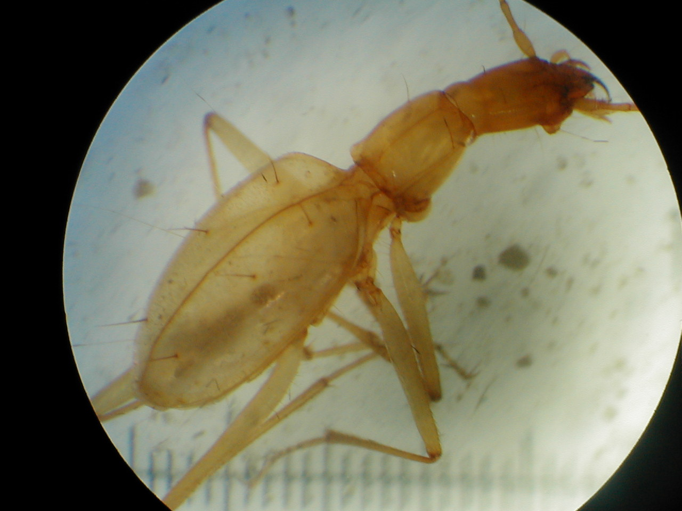

Figure 30: New species of blind trechine carabid beetle collected from Shendong (in Lingyun County, NW Guangxi Province) by Arthur Clarke in early October 2000. Note the translucent depigmented body, long sensory spines and long appendages. The species has recently been described as Guizhaphaenops (Guiaphaenops) lingyunensis n. subgen., n. sp. (Deuve, 2002).

Shang Niu Dong
Altitude: 700m; total plan length = 750.43m; vertical range = 75.03m. The (7m x 7m) porch-like entrance to this cave is situated in a rock face on the side of a valley near where there are a number of swallet entrances. The draughting entrance passage leads to a 20m pitch, beyond which is a sizeable (15m x 10m) passage leading to another series of small waterfall pitches. Following yet another pitch is a series of confusing but fairly well decorated passages.

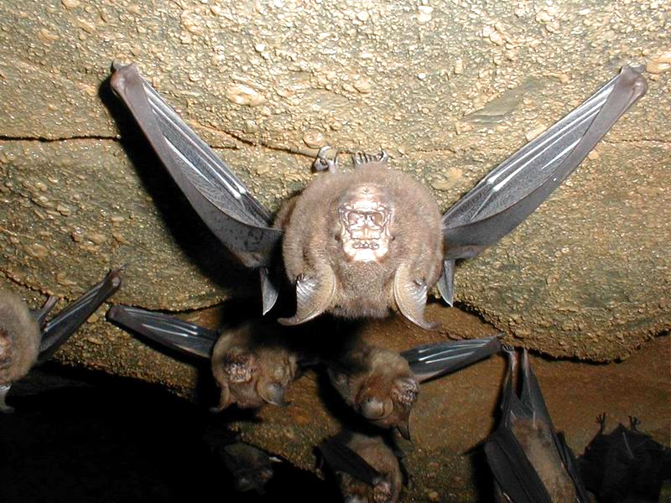

Figure 31: Leaf-nosed bats: Hipposideros amiger (Hipposoderidae) roosting on the fossiliferous bedding plane ceiling of a low-roofed stream passage in Shendong.

Xiashuidong (= Sinking Water Cave)
Altitude: 681m; total plan length = 668.25m; vertical range = 154.34m. This is a predominantly vertical cave with waterfall pitches, numerous sumps, blind pits and muddy stream passage sections. Explored over a 4-day period, numerous leads were pursued. The cave continues, but there is one large chamber (estimated to be 80m deep), which could not be descended due to loose rock at the pitch head.

Hang Lian Doline (doline near Shadong)
Altitude: 843m; vertical range = 300m. Hang Lian Dong is a large steep 300m deep doline, that is densely forested. This doline was descended via two vertical descents, the longest of which was 70m.

(b) Karst Area south of Lingyun (see map in Figure 26)

Only two days were allocated to exploration of this region which still has considerable potential for deep caves and large subterranean river systems. One undescended vertical cave beside the Lingyun to Bose road has a recorded eight second drop to an echoing chamber at unknown depth.

Yan Liudong/ Yanliu Suidao (= Rock Flow Cave/ Rock Flow Tunnel)
Altitude: 432m; vertical range = 220m. Yan Liudong is a massive cliff-walled collapse doline (100m wide x 200m deep), at the bottom of which there are 40m high steep silt banks descending to the turbulent river below. This entrance was descended by a 150m free-hanging abseil (see Figures 32 ,33 and 38). The overflow floodwaters from the underground river in Yan Liudong have been channelled into the Xigia hydroelectric scheme via a diversion tunnel (Yanliu Suidao) formed in part by the artificial enlargment and extension of a natural cave

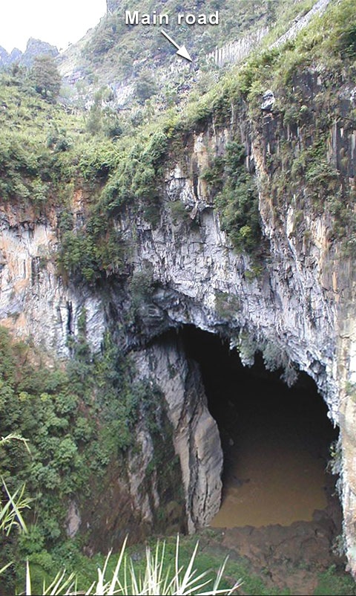

Figure 32: Looking down the 200m deep entrance of Yanliu Suidao; arrow shows road above.

passage. Cave adapted ecotypes of siluriform catfish and a white microphthalmic decapod crab were discovered were discovered in this Yanliu Suidao tunnel passage. Only partially surveyed for a length of 1½km, Yanliu Suidao connects to an outlet branch passage where an irrigation pipe leads out to a muddy-bottomed doline that is actively farmed in the dry season.

